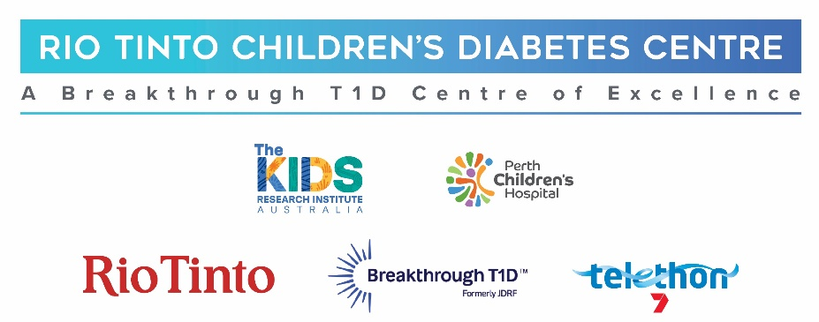

Research findings
Revisiting hypoglycaemia management in children with Type 1 diabetes on contemporary therapy

Age Range: 2 to 18 years


What was the aim?
Hypoglycaemia (hypo; or low glucose) is a common occurrence in people living with Type 1 diabetes. Current clinical guidelines suggest treating hypo events when glucose levels fall below 3.9 mmol/L, when symptomatic or when there is physical activity occurring and they are trending downwards (with down arrows on their CGM device). With the changing landscape of technology use, families have been noted to change their management strategies to best suit their personal responses and lifestyle.

The aim of this study was to understand the experiences of hypos in daily life, and how families adapt the current hypo education provided in clinic. This included reviewing the personalised thresholds that families choose to treat hypos and what foods are chosen to treat hypos.

How did we do it?
Families of children and adolescents living with Type 1 diabetes who are seen at diabetes clinics at Perth Children’s Hospital, including the outer metro and regional clinics, were invited to take part in a survey, consisting of six or seven sections depending on the age of the child. Caregivers of children under the age of 12 years completed the survey on the child’s behalf, with adolescents over 12 years old completing the survey with support of their caregivers. Funding was provided by a Stan Perron-supported Perth Children’s Hospital Foundation grant.

What did we find?
We found a lot of variation in how, when and with what foods people choose to treat hypos with.

We had 271 respondents to the first six sections. Approximately 54% of the respondents treat hypos at the recommended threshold. The majority of families (~89%) change this threshold based on different factors, such as time of day, active insulin on board and exercise. Families also reported using a wide variety of foods to treat hypos, some more effective than others.

What does this mean?
Families report having a variety of different ways of managing hypos. It also shows that the current hypo education needs to be revisited, especially with the use of hybrid closed loop (HCL) therapy. The findings have been used to develop a current clinical trial looking at redefining the hypo threshold used. We have also created a traffic light guide with different foods to aid families in choosing more effective hypo treatments, which can be discussed with your dietitian in clinic.

For further information: e | Diabetes.Research@health.wa.gov.au
t | (08) 6456 8976
w | diabetes.thekids.org.au

